Setting Up Flare

Getting Flare set up properly will ensure that all writers can retrieve, update, and add new content for use and reuse in documentation.

|  |  |
| --- | --- |
| Note: | All writers MUST follow these steps or Flare may not work properly! |

Overview of Flare Documentation Process

Working on documentation in Flare provides many benefits for writers, but can be a much different process than a writer is used to. This section will provide a high-level introduction on how Flare works and a general overview of creating documentation.

How Flare Works - Single-Source Editing

Flare is a single-source document editor and content management system (CMS). Single-source editing means that text or files only need to be created once, and can then be reused in any number of documents. The biggest benefit this offers writers is that any updates in the source will then be reflected in all other documentation using the same source.

For example, a writer creates a topic about how to log into a work computer using the VPN. This topic is then used in different documents - one that is to be included as a printout with new employees' computers, one that provides an overview of different ways an employee can connect to the SAMPLE network, and another that is a new employee handbook.

If a system update changes the way connecting to the VPN works, the writer only needs to edit the source topic. Now, when the printout, connecting to SAMPLE network, or employee handbook are generated, they will all use the updated text, since they all pull from the same single source.

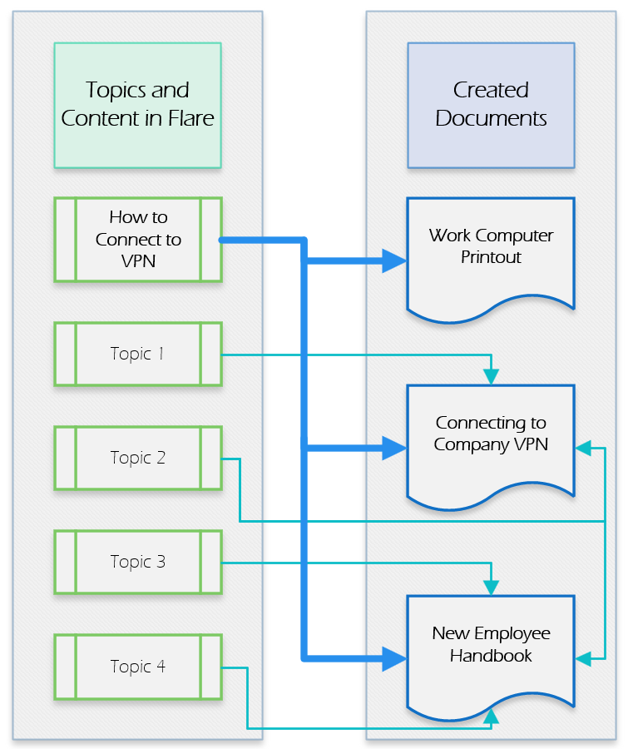

Setting Up Flare File Structure

It is important that all writers maintain a consistent file structure when working with Flare, so that projects update and open correctly on all machines. By default, Flare uses the Documents folder located in each user's SAMPLE OneDrive folder, resulting in each writer having a different file path.

To ensure every writer can work with all Flare projects correctly, Flare will be setup to use the following folders on each user's computer:

* C:\Flare
* C:\Flare\Projects
* C:\Flare\Templates
* C:\Flare\Templates\Projects

To create these folders so they are available during the Flare setup process, do the following:

1. Open Windows File Explorer. By default, this is available by clicking the folder icon near the Start menu.



1. Scroll to the bottom of the side-menu and expand This PC and click the (C:) drive.

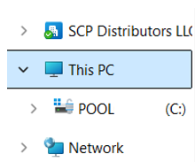

1. Click New, select Folder, and name it Flare.
2. Inside the Flare folder, make a Projects and a Templates folder.
3. Inside the Templates folder, create another Projects folder.
4. With these folders in place, the writer can continue setup.

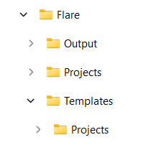

|  |  |
| --- | --- |
| Note: | The Output folder seen in the screenshot is generated automatically when a document is built, and does not need to be created at this step. |

Adjusting Flare Settings

Flare can be customized in many ways to suit each user's preference. However, there are a few options which should be set in a particular way to ensure everything works properly.

1. Click File and select Options.
2. It is highly recommended to set an auto-save interval in the General tab. Check the Auto-Save Documents box and set the time between auto-saves in minutes.
3. In the Source Control tab, ensure the following options are checked:
   * Automatically check file out from source control when saving file changes
   * Lock files when automatically checking out files (files cannot be checked in by other users)
   * Show prompt to add auto-created files to source control
   * Prompt to check in files when closing source control bound projects
4. In the Review tab, add your full name and initials in the User Name and Initials fields, respectively.
5. When finished, click OK.
6. Click View in the ribbon, and ensure the Status Bar option is checked in the Info group.

Connecting to MadCap Central

MadCap Central is the "cloud" component of Flare. Among other features, it serves as the team's source control; this is what contains and synchronizes changes with all writers' work. Additionally, it saves the history of changes that writers make, making it easy to find what was changed and when, and allowing those changes to be reverted, if needed.

There are three main components of working with Central when getting started in Flare: connecting to Central, importing projects from Central, and learning the basic actions of Source Control.

Logging into MadCap Central in Flare

1. Click Log In, located on the right of Flare's title bar.

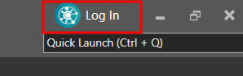

1. The next login screen will depend on whether or not Flare is already connected with SAMPLE's single sign-on (SSO). If SAMPLE is displayed with a Log in with SSO button, go to the next step.

Otherwise, Log in with MadCap ID is shown.

* 1. There is no need to fill in the fields on this screen. Click the Log in to a specific license button.

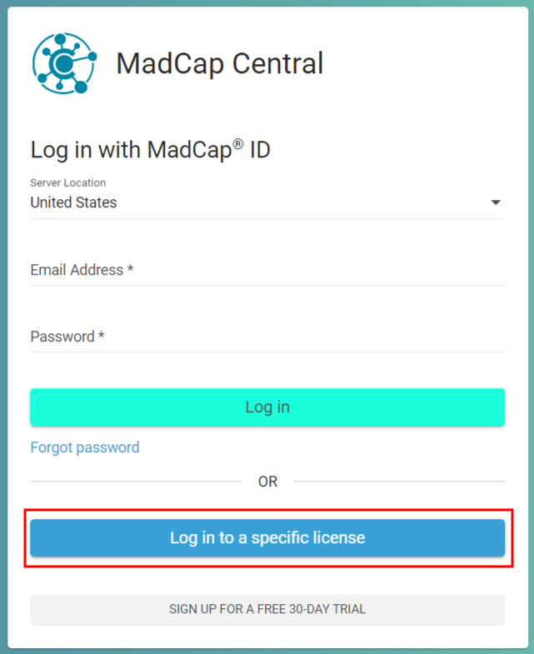

* 1. On the Enter your license vanity to log in screen, type SAMPLE and click Continue.

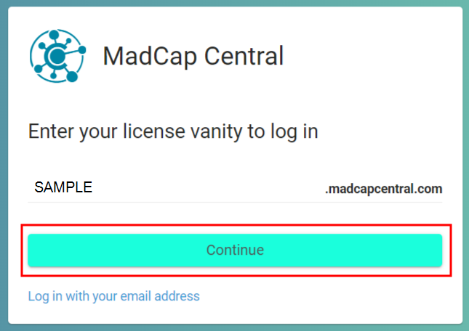

1. Click Log in with SSO, and log in using your SAMPLE credentials.

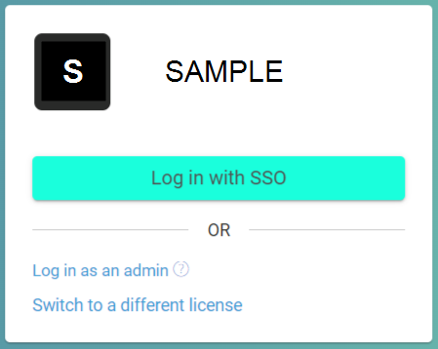

1. You should now be connected to Central with your SAMPLE account. Open the MadCap Central pane either by clicking your initials/profile picture in the right of Flare's title bar and selecting Open Central Pane, or clicking View and selecting MadCap Central in the ribbon.

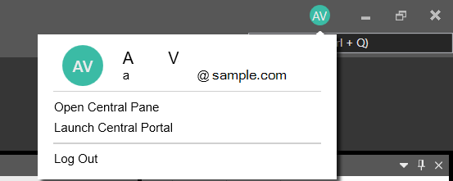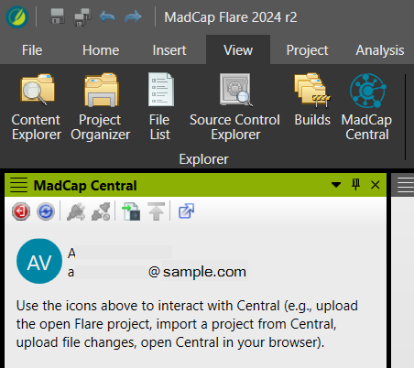

Importing Projects from Central

After connecting Flare with Central, it is time to import projects. Projects in Flare contain related topics and files, allowing writers to add, edit, and reuse content and produce multiple documents from the same project.

|  |  |
| --- | --- |
| Note: | Each project only needs to be imported once. Note that the TEMPLATE project is unique and must be imported first and into a different folder than the other projects. |

1. In the MadCap Central pane, click the Import a project from MadCap Central icon. The Import Project window opens.
2. Under the My Projects drop-down, select TEMPLATE.
3. Use the ellipsis icon to navigate to C:\Flare\Templates\Projects.
4. Ensure that the the TEMPLATE project is selected, and that the file path is correct and then click OK.
5. The Select project file drop-down should prepopulate with the project file, which has the file extension .flprj. Click Finish.
6. Repeat the process to import the other projects, this time to the C:\Flare\Projects folder.

|  |
| --- |
| Notes:   * The TEMPLATE project must be imported first, to its unique path in C:\Flare\Templates\Projects, as all other projects are linked to it. * Projects other than the TEMPLATE project should be located in C:\Flare\Projects. * Once the TEMPLATE is imported, the other projects technically only need to be imported as needed, depending on what the writer is working on. |

Project Descriptions

The projects available to writers are as follows:

* Hardware_Software: Documentation which is primarily focused on the usage of, or information regarding, software and hardware. For example, Sample360 services, Microsoft programs, or terminal setup.
* Policies_Practices_Procedures: Documentation that is primarily related to processes. For example, onboarding procedures, company policies, or communication processes.
* Sandbox_Project: A project that writers can use to try out and test features of Flare without affecting other projects.
* TEMPLATE: A project set up for use as a template for all other projects. Any changes to this project will be reflected in all other projects. As a general rule, writers should NOT work in or edit this project.

Starting a New Document in Flare

To begin work on a new document, writers will create the necessary components in Flare and a branch to work from. Branching is a part of source control that allows a user to work on a project without affecting the master branch, which means that works-in-progress will not appear among any finalized documentation. When a writer has finished a document (including any needed reviews and approvals), their working branch will be merged into the master branch so that their new documentation is available for all.

For the purposes of setup, this section will not get into detail about branching, source control, and other Flare components, but more information about these will follow.

Creating a Working Branch

1. In the Source Control ribbon, click the arrows above Branch to open the Branch Management window.
2. Click Create to open the Create Branch window, and fill out the fields.
   1. Source Branch: Select master from the drop-down menu.
   2. Branch Name: Enter the writer's initials, a slash, and then a short, descriptive name for the branch. This might be the document's title or a specific feature being updated by the writer. Branch names cannot have spaces and should be replaced with hyphens.
   3. Switch to branch: Select this box to switch to the new branch once it is created, otherwise leave it unchecked.

|  |  |
| --- | --- |
| Note: | If there are any open files that have not been committed via source control, a warning will appear. Switching branches before committing will overwrite those files, and work will be lost. |

1. Click Create to create the branch.

Creating Targets and TOCs

1. In the Project Organizer, open the Targets folder.
2. Copy the _Target_Templates folder either by right-clicking the folder and selecting Copy, or selecting the folder and pressing Ctrl + C.
3. If there is an appropriate folder for the document, paste (Ctrl + P) the copy into it. Otherwise, make an appropriate folder structure for the document within the Targets folder and paste it into the created folder.  
   For example, if the document is related to Flare, the target could be copied into Targets > MadCap > Flare. A document related to Sample360 SampleTest could go into Targets > Sample360 > SampleTest.
4. Rename the copied folder to reflect the title of the document.

|  |
| --- |
| Notes:   * Folder and file names in Flare should not contain spaces.Use dashes in place of spaces. * Keep in mind the location and name used for the document, as this will be mimicked in other parts of setup. |

1. In the Project Organizer, open the TOCs folder and expand the _TOC_Templates folder.
2. Copy the _TOC_Template file.
3. Mirroring the location used in the Targets folder, paste the file into the same location within the TOCs folder, creating folders if needed.  
   For example, if the Target folder was put into Targets > MadCap > Flare, paste the TOC template file into TOCs > MadCap > Flare.
4. Rename the TOC file with the same name used when renaming the Targets folder.

Editing the Targets and TOC

1. In the Content Explorer pane, copy, paste, and rename the _New_Doc_Templates folder, mirroring the location used for Targets and TOCs in the Content folder.
2. Open the Project Organizer pane.
3. Navigate to the created Target folder, and expand it if necessary.

|  |  |
| --- | --- |
| Note: | These steps must be repeated for each target file in the folder. |

1. Double-click a target to open the Target Editor.

In the General tab, select the TOC created for this document from the Primary TOC drop-down.

1. In the Conditional Text tab, adjust any exclusions or inclusions as necessary. In particular, the DocumentParts tag set is where a cover page and/or TOC can be included.
2. In the Variables tab, select the Project Variables variable set and update the Author, ContactEmail, DocTitle, and CoverPage variables.
3. Save the file.
4. Navigate to the created TOC file, and double-click to open the TOC editor.
5. Expand the Document folder, and expand the Content folder. The Front-Pages file and folders should be left as-is.
6. Right-click the Intro-Template file and select Properties.
7. In the General tab, under Link, click the blue Select Link button.
8. In the Select File window, navigate and choose the Intro topic located in the Content folder made for the document.
9. Repeat the process for the Topic-Template file, selecting the Topic instead of the Intro.

Creating Documents in Flare

The majority of documentation creation in Flare is the process of creating and assembling Topics in the relevant TOC, and building the necessary Targets. Roughly speaking, the TOC dictates which and in what order the topics appear in the full document. Targets dictate how the document appears - for example, there are separate Targets for PDF and Word output. Topics are the actual written content.

Creating Topics

In general, a Topic should only contain as much information as needed to explain the topic but still be understandable when standing alone. This is to ensure that topics can be easily reused as needed in various documents that may not be related but contain the same information - for example, a topic might explain how to add an image in Flare. Since this topic could be used in multiple guides, the writer should be mindful of wording and specificity, and use conditional tags when appropriate.

This can feel counter-intuitive when used to working in other documentation software where all content is visible at once, in the order it will appear. It may help to write a document or sections of a document first in larger topics and split into smaller ones after the writer has finished the "flow" of writing.

There are several ways to create topics in Flare, but only two will be discussed here: Creating a Topic via Content Explorer, and Creating a Topic From Within a TOC.

To create a Topic in the Content Explorer, do the following:

1. Open the Content Explorer pane.
2. Navigate or create the folder in which to create the new Topic.
3. Right-click the folder and select New > Topic, or select the folder and press Ctrl + T.
4. In the Add File window that opens, edit the following:
   * Source: Select either New from template or New from existing, and select the desired template.
   * Topic: For Folder, ensure this displays the correct path for the new topic. If not, click the ellipsis to browse to the desired path. For File Name, add a descriptive name for the new topic (do not use spaces; use hyphens instead. Preferably title-case)
   * Advanced: (Optional) Write the 1st Heading and Title of the topic.
5. Click Add.

To create a Topic from a TOC, do the following:

1. Open the TOC in which to add the new Topic.
2. Navigate or create the folder in which to create the new Topic.
3. Right-click the folder and select Add New Topic.
4. In the Add File window that opens, edit the following:
   * Source: Select either New from template or New from existing, and select the desired template.
   * Topic: For Folder, ensure this displays the correct path for the new topic. If not, click the ellipsis to browse to the desired path. For File Name, add a descriptive name for the new topic (do not use spaces; use hyphens instead. Preferably title-case)
   * Advanced: (Optional) Write the 1st Heading and Title of the topic.
5. Click Add.

The benefit of adding Topics in the TOC is that the newly created topic is included in that TOC, meaning it does not have to be manually added later.

Working with TOCs

TOC files determine which topics appear in a document and in what order.

* Topics in a TOC can be re-arranged by simply dragging and dropping them.
* Existing topics can be added to a TOC in different ways, but the easiest method is by dragging and dropping the Topic from the Content Explorer into the appropriate folder in the TOC file.

Adding Images

* Images should be added to a folder mirroring the Target and TOC file paths in _Resources/Images in the content explorer.
* The image names should be descriptive, and use no spaces.
* Icons or logos that may be applicable across different SAMPLE documents can be added to the _Resources/Images/_LogosAndIcons folder. Try to include the highest quality/largest version of the image as possible.
* Images can be added to a topic by dragging and dropping it from the Content Explorer into the Topic. With the image selected, use the Paragraph options in the Home ribbon to center the image. (Note: Images should automatically get the blue border, but there are options to remove it, if needed.)

Building Targets And Producing Document Files

* To create a PDF or Word version of the document, navigate to that document's Targets folder in the Project Organizer.
* Right-click either the PDF or Word target (depending on the desired file type) and click Build.
* Double-click the Project in the Builds pane when the Status says Finished to open the file.
* The file will be located in C:/Flare/Output/<file path>/<Target name>

Finishing Documents in Flare

When a document has gone through all reviews and edits and is deemed "finished," the writer will finish the project by merging their working branch into the master branch, and copying their output into the appropriate folder in Teams.

Merging a Working Branch into the Master Branch

The Master branch serves as the "single source of truth" containing only content that has been thoroughly reviewed and approved by all necessary parties. When content is being updated, it should "live" in a writer's working branch to keep works-in-progress separate from finalized work.

To merge a working branch into the Master branch:

1. Ensure all changes in the working branch have been committed by opening the Source Control ribbon and clicking Commit All in the Project group.
2. Switch to the Master branch by clicking the drop-down next to the current branch in the status bar and selecting master. If the branch has changes since the last commit, a warning will appear that these changes will be lost if the branch is switched before these are committed.
3. Open the Source Control Ribbon, and click Merge in the Branch group.